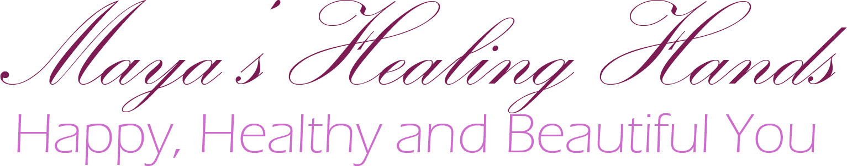

CHOOSING AND BOOKING YOUR TREATMENT

When choosing your ideal treatment, use all the available information. Browse the website, blog posts, social media and reviews to get an idea of what is it that you need. There is a lot of great advice out there to help you make a better choice.

If using the message box on the website, you should get your reply within a few hours, but at busy times you might wait up to 24 hours.

Try to fit as many of your questions and requests into your initial message, as it will really speed up our communication. Don't forget to mention your chosen treatments, questions about them and choice of preferred appointment dates and times.

PAYING FOR YOUR TREATMENTS OR GIFTS

Your treatment needs to be paid for in full at the time of your appointment. You can choose to pay by cash, cheque, bank transfer or PayPal payment.

Gift vouchers are to be paid for at the time of ordering, before receiving the hard copy or a printable version.

Your first session at Maya's Healing Hands is secured by deposit of £20 paid by PayPal. Outstanding balance for the treatment can be either cleared at the same time, or paid by cash at the time of treatment.

Upon receiving a confirmation message, your appointment is secured and obligatory

CHANGING OR CANCELING YOUR APPOINTMENT

If for any reason you can't make it to your appointment, you can either change it or cancel it free of charge up to 24 hours prior to the treatment time.

A late cancellation fee of £20 applies to all the treatments cancelled less than 24 hours prior to treatment, and need to be cleared within 24 hours of receiving a message with a PayPal link

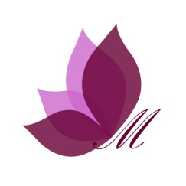
If for any reason you should fail to pay your late cancellation fine, the next appointment will only be secured after clearing the debt and paying for the next treatment in full at the time of booking.

